
Order
Support & Community
Tools & Software
Product Folder
Technical
Documents
o o Now

SN65HVD230, SN65HVD231, SN65HVD232
SLOS346O –MARCH 2001 –REVISED APRIL 2018
SN65HVD23x 3.3-V CAN Bus Transceivers

1 Features
• Operates with a single 3.3 V Supply
• Compatible With ISO 11898-2 Standard
• Low Power Replacement for the PCA82C250 Footprint
• Bus Pin ESD Protection Exceeds ± 16 kV HBM
• High Input Impedance Allows for Up to 120 Nodes on a Bus
• Adjustable Driver Transition Times for Improved Emissions Performance
– SN65HVD230 and SN65HVD231
• SN65HVD230: Low Current Standby Mode
– 370 μA Typical
• SN65HVD231: Ultra Low Current Sleep Mode
– 40 nA Typical
• Designed for Data Rates(1) up to 1 Mbps
• Thermal Shutdown Protection
• Open Circuit Fail-Safe Design
• Glitch Free Power Up and Power Down Protection for Hot Plugging Applications
(1) The signaling rate of a line is the number of voltage
transitions that are made per second expressed in the units bps (bits per second).

2 Applications
• Industrial Automation, Control, Sensors and Drive Systems
• Motor and Robotic Control
• Building and Climate Control (HVAC)
• Telecom and Basestation Control and Status
• CAN Bus Standards Such as CANopen, DeviceNet, and CAN Kingdom

3 Description
The SN65HVD230, SN65HVD231, and SN65HVD232 controller area network (CAN) transceivers are compatible to the specifications of the ISO 11898-2 High Speed CAN Physical Layer standard (transceiver). These devices are designed for data rates up to 1 megabit per second (Mbps), and include many protection features providing device and CAN network robustness. The SN65HVD23x transceivers are designed for use with the Texas Instruments 3.3 V µPs, MCUs and DSPs with CAN controllers, or with equivalent protocol controller devices. The devices are intended for use in applications employing the CAN serial communication physical layer in accordance with the ISO 11898 standard.
Device Information(1)

PART NUMBER | PACKAGE | BODY SIZE (NOM)
SN65HVD230 | SOIC (8) | 4.90 mm × 3.91 mm
SN65HVD231 | SOIC (8) | 4.90 mm × 3.91 mm
SN65HVD232 | SOIC (8) | 4.90 mm × 3.91 mm
(1) For all available packages, see the orderable addendum at the end of the datasheet.





Equivalent Input and Output Schematic Diagrams
VCC VREF
B IAS UNIT
D

RS
VCC
VCC
SLOPE CONTROL
VCC
VCC
Thermal Shutdown
VCC / 2
and MODE LOGIC
NC
R
' ·

GND

An IMPORTANT NOTICE at the end of this data sheet addresses availability, warranty, changes, use in safety-critical applications, intellectual property matters and other important disclaimers. PRODUCTION DATA.

Table of Contents

1 Features 1
2 Applications 1
3 Description 1
4 Revision History 2
5 Description (continued) 4
6 Device Comparison Table 4
7 Pin Configuration and Functions 5
8 Specifications 5
8.1 Absolute Maximum Ratings 5
8.2 ESD Ratings 6
8.3 Recommended Operating Conditions 6
8.4 Thermal Information 6
8.5 Electrical Characteristics: Driver 7
8.6 Electrical Characteristics: Receiver 7
8.7 Switching Characteristics: Driver 8
8.8 Switching Characteristics: Receiver 8
8.9 Switching Characteristics: Device 8
8.10 Device Control-Pin Characteristics 9
8.11 Typical Characteristics 10
9 Parameter Measurement Information 13
10 Detailed Description 19

10.1 Overview 19
10.2 Functional Block Diagram 19
10.3 Feature Description 20
10.4 Device Functional Modes 20
11 Application and Implementation 25
11.1 Application Information 25
11.2 Typical Application 26
11.3 System Example 30
12 Power Supply Recommendations 32
13 Layout 33
13.1 Layout Guidelines 33
13.2 Layout Example 34
14 Device and Documentation Support 35
14.1 Related Links 35
14.2 Receiving Notification of Documentation Updates 35
14.3 Community Resources 35
14.4 Trademarks 35
14.5 Electrostatic Discharge Caution 35
14.6 Glossary 35
15 Mechanical, Packaging, and Orderable
Information 35

4 Revision History
NOTE: Page numbers for previous revisions may differ from page numbers in the current version.
Changes from Revision N (July 2015) to Revision O Page
• Changed Slope Control Resistance - kW To: Slope Control Resistance - kΩ in Figure 33 22
• Changed Driver Output Signal Slope - V/ms To: Driver Output Signal Slope - V/µs in Figure 33 22
Changes from Revision M (May 2015) to Revision N | Page
• Changed the data sheet title From; SN65HVD230x 3.3-V CAN Bus Transceivers To: SN65HVD23x 3.3-V CAN Bus
Transceivers .......................................................................................................................................................................... 1
Changes from Revision L (January 2015) to Revision M | Page
• Changed Figure 44 title From: "Layout Example Schematic" To: "SN65HVD23x Board Layout"........................................ 34
Changes from Revision K (February 2011) to Revision L | Page
• Added Pin Configuration and Functions section, ESD Ratings table, Feature Description section, Device Functional
Modes, Application and Implementation section, Power Supply Recommendations section, Layout section, Device
and Documentation Support section, and Mechanical, Packaging, and Orderable Information section 1
• Changed the list of Features, Applications, and Description 1
• Added THERMAL SHUTDOWN TEMPERATURE AND HYSTERESIS in the Recommended Operating Conditions table. 6
• Added the THERMAL SHUTDOWN paragraph to the Application Information section 20
• Added Figure 34 and Figure 35 25
• Added the CAN TERMINATION paragraph to the Application Information section 26
• Added the BUS LOADING, LENGTH AND NUMBER OF NODES paragraph to the Application Information section 28


SN65HVD230, SN65HVD231, SN65HVD232
www.ti.com SLOS346O –MARCH 2001 –REVISED APRIL 2018

Changes from Revision J (January 2009) to Revision K | Page
• Replaced the DISSIPATION RATING TABLE with the Thermal Information table................................................................ 6
Changes from Revision I (October 2007) to Revision J | Page
• Deleted Low-to-High Propagation Delay Time vs Common-Mode Input Voltage Characteristics 12
• Deleted Driver Schematic Diagram 12
• Added Figure 38 32


SN65HVD230, SN65HVD231, SN65HVD232
SLOS346O –MARCH 2001 –REVISED APRIL 2018 www.ti.com

5 Description (continued)
Designed for operation in especially harsh environments, these devices feature cross wire protection, loss of ground and overvoltage protection, overtemperature protection, as well as wide common mode range of operation.
The CAN transceiver is the CAN physical layer and interfaces the single ended host CAN protocol controller with the differential CAN bus found in industrial, building automation, and automotive applications. These devices operate over a -2 V to 7 V common mode range on the bus, and can withstand common mode transients of ±25 V.
The RS pin (pin 8) on the SN65HVD230 and SN65HVD231 provides three different modes of operation: high speed mode, slope control mode, and low-power mode. The high speed mode of operation is selected by connecting the RS pin to ground, allowing the transmitter output transistors to switch on and off as fast as possible with no limitation on the rise and fall slopes. The rise and fall slopes can also be adjusted by connecting a resistor in series between the RS pin and ground. The slope will be proportional to the pin's output current. With a resistor value of 10 kΩ the device will have a slew rate of ~15 V/μs, and with a resistor value of 100 kΩ the device will have a slew rate of ~2 V/μs. See Application Information for more information.
The SN65HVD230 enters a low current standby mode (listen only) during which the driver is switched off and the receiver remains active if a high logic level is applied to the RS pin. This mode provides a lower power consumption mode than normal mode while still allowing the CAN controller to monitor the bus for activity indicating it should return the transceiver to normal mode or slope control mode. The host controller (MCU, DSP) returns the device to a transmitting mode (high speed or slope control) when it wants to transmit a message to the bus or if during standby mode it received bus traffic indicating the need to once again be ready to transmit.
The difference between the SN65HVD230 and the SN65HVD231 is that both the driver and the receiver are switched off in the SN65HVD231 when a high logic level is applied to the RS pin. In this sleep mode the device will not be able to transmit messages to the bus or receive messages from the bus. The device will remain in sleep mode until it is reactivated by applying a low logic level on the RS pin.

6 Device Comparison Table

PART NUMBER(1) | LOW POWER MODE | INTEGRATED SLOPE  CONTROL | Vref PIN | TA | MARKED AS:
SN65HVD230 | Standby mode | Yes | Yes | 40°C to 85°C | VP230
SN65HVD231 | Sleep mode | Yes | Yes | 40°C to 85°C | VP231
SN65HVD232 | No standby or sleep mode | No | No | 40°C to 85°C | VP232
(1) For the most current package and ordering information, see Mechanical, Packaging, and Orderable Information, or see the TI web site at www.ti.com.

SN65HVD230, SN65HVD231, SN65HVD232
www.ti.com SLOS346O –MARCH 2001 –REVISED APRIL 2018

7 Pin Configuration and Functions

1 8
2 7
3 6
4 5
SN65HVD230D (Marked as VP230)
SN65HVD231D (Marked as VP231)
Top View
RS
CANH
CANL
Vref
D
GND
V CC
R
Not to scale

D
GND
V CC
R
Not to scale
1 8 NC
2 7 CANH
3 6 CANL
4 5 NC
SN65HVD232D (Marked as VP232)
Top View

Pin Functions

PIN |  | TYPE | DESCRIPTION
NAME | NO. | TYPE | DESCRIPTION
D | 1 | I | CAN transmit data input (LOW for dominant and HIGH for recessive bus states), also called TXD, driver input
GND | 2 | GND | Ground connection
V CC | 3 | Supply | Transceiver 3.3V supply voltage
R | 4 | O | CAN receive data output (LOW for dominant and HIGH for recessive bus states), also called RXD, receiver output
V ref | 5 | O | SN65HVD230 and SN65HVD231: V CC / 2 reference output pin
NC | 5 | NC | SN65HVD232: No Connect
CANL | 6 | I/O | Low level CAN bus line
CANH | 7 | I/O | High level CAN bus line
RS | 8 | I | SN65HVD230 and SN65HVD231: Mode select pin: strong pull down to GND = high speed mode, strong pull up to V CC = low power mode, 10kΩ to 100kΩ pull down to GND = slope control mode
NC | 8 | I | SN65HVD232: No Connect

8 Specifications

8.1 Absolute Maximum Ratings
over operating free-air temperature range (unless otherwise noted)(1)(2)

 | MIN MAX | UNIT
Supply voltage, V CC | –0.3 6 | V
Voltage at any bus terminal (CANH or CANL) | –4 16 | V
Voltage input, transient pulse, CANH and CANL, through 100 Ω (see Figure 24) | –25 25 | V
Digital Input and Output voltage, VI (D or R) | –0.5 V CC + 0.5 | V
Receiver output current, IO | –11 11 | mA
Continuous total power dissipation | See Thermal Information
Storage temperature, Tstg | –40 85 | °C
(1) Stresses beyond those listed under Absolute Maximum Ratings may cause permanent damage to the device. These are stress ratings only, and functional operation of the device at these or any other conditions beyond those indicated under Recommended Operating Conditions is not implied. Exposure to absolute-maximum-rated conditions for extended periods may affect device reliability.
(2) All voltage values, except differential I/O bus voltages, are with respect to network ground terminal.

SN65HVD230, SN65HVD231, SN65HVD232
SLOS346O –MARCH 2001 –REVISED APRIL 2018 www.ti.com

8.2 ESD Ratings

 |  |  |  | VALUE | UNIT
Electrostatic V(ESD) discharge | Human  001 (1) | body model (HBM), per ANSI/ESDA/JEDEC JS- | CANH, CANL and GND | ± 16000 | V
Electrostatic V(ESD) discharge | Human  001 (1) | body model (HBM), per ANSI/ESDA/JEDEC JS- | All pins | ±4000 | V
Electrostatic V(ESD) discharge | Charged-device model (CDM), per JEDEC specification JESD22-C101 (2) |  |  | ± 1000 | V
(1) JEDEC document JEP155 states that 500-V HBM allows safe manufacturing with a standard ESD control process.
(2) JEDEC document JEP157 states that 250-V CDM allows safe manufacturing with a standard ESD control process.

8.3 Recommended Operating Conditions

 |  | MIN NOM MAX | UNIT
Supply voltage, V CC |  | 3 3.6 | V
Voltage at any bus terminal (common mode) VIC |  | –2(1) 7 | V
Voltage at any bus terminal (separately) VI |  | –2.5 7.5 | V
High-level input voltage, VIH | D, R | 2 | V
Low-level input voltage, VIL | D, R | 0.8 | V
Differential input voltage, VID (see Figure 22) |  | –6 6 | V
Input voltage, V(Rs) |  | 0 V CC | V
Input voltage for standby or sleep, V(Rs) |  | 0.75 VCC V CC | V
Wave-shaping resistance, Rs |  | 0 100 | kΩ
High-level output current, I OH | Driver | –40 | mA
High-level output current, I OH | Receiver | –8 | mA
Low-level output current, I OL | Driver | 48 | mA
Low-level output current, I OL | Receiver | 8 | mA
Thermal shutdown temperature |  | 165 | °C
Thermal shutdown hysteresis |  | 10 | °C
Operating free-air temperature, TA |  | –40 85 | °C
(1) The algebraic convention, in which the least positive (most negative) limit is designated as minimum is used in this data sheet.

8.4 Thermal Information

THERMAL METRIC(1) | SN65HVD230 | SN65HVD231 | SN65HVD232 | UNIT
THERMAL METRIC(1) | D |  |  | UNIT
THERMAL METRIC(1) | 8 PINS |  |  | UNIT
RθJA Junction-to-ambient thermal resistance | 76.8 | 101.5 | 101.5 | °C/W
RθJC(top) Junction-to-case (top) thermal resistance | 33.4 | 43.3 | 43.3 | °C/W
RθJB Junction-to-board thermal resistance | 15.3 | 42.2 | 42.4 | °C/W
ψJT Junction-to-top characterization parameter | 1.4 | 4.8 | 4.8 | °C/W
ψJB Junction-to-board characterization parameter | 14.9 | 41.8 | 41.8 | °C/W
(1) For more information about traditional and new thermal metrics, see the Semiconductor and IC Package Thermal Metrics application report.

SN65HVD230, SN65HVD231, SN65HVD232
www.ti.com SLOS346O –MARCH 2001 –REVISED APRIL 2018

8.5 Electrical Characteristics: Driver
over recommended operating conditions (unless otherwise noted)

PARAMETER |  |  |  | TEST CONDITIONS |  | MIN TYP(1) MAX | UNIT
V OH | Bus output voltage | Dominant |  | VI = 0 V,  See Figure 18 and Figure 20 | CANH | 2.45 V CC | V
 |  |  |  |  | CANL | 0.5 1.25 | V
VOL | Bus output voltage | Recessive |  | VI = 3 V,  See Figure 18 and Figure 20 | CANH | 2.3 | V
 |  |  |  |  | CANL | 2.3 | V
VOD(D) | Differential  output voltage | Dominant |  | VI = 0 V, See Figure 18 |  | 1.5 2 3 | V
VOD(D) | Differential  output voltage |  |  | VI = 0 V, See Figure 19 |  | 1.2 2 3 | V
VOD(R) | Differential  output voltage | Recessive |  | VI = 3 V, See Figure 18 |  | –120 0 12 | mV
VOD(R) | Differential  output voltage |  |  | VI = 3 V, No load |  | –0.5 –0.2 0.05 | V
IIH High-level input current |  |  |  | VI = 2 V |  | –30 | μA
IIL Low-level input current |  |  |  | VI = 0.8 V |  | –30 | μA
IOS Short-circuit output current |  |  |  | VCANH = -2 V |  | –250 250 | mA
 |  |  |  | VCANL = 7 V |  | –250 250 | mA
Co Output capacitance |  |  |  | See receiver
ICC | Supply  current | Standby | SN65HVD230 | V(Rs) = V CC |  | 370 600 | μA
ICC | Supply  current | Sleep | SN65HVD231 | V(Rs) = V CC, D at V CC |  | 0.04 1 | μA
ICC | Supply  current | All devices | Dominant | VI = 0 V, No load | Dominant | 10 17 | mA
ICC | Supply  current | All devices | Recessive | VI = V CC, No load | Recessive | 10 17 | mA
(1) All typical values are at 25°C and with a 3.3-V supply.

8.6 Electrical Characteristics: Receiver
over recommended operating conditions (unless otherwise noted)

PARAMETER | TEST CONDITIONS |  | MIN TYP(1) MAX | UNIT
VIT+ Positive-going input threshold voltage | See Table 1 |  | 750 900 | mV
VIT- Negative-going input threshold voltage |  |  | 500 650 | mV
Vhys Hysteresis voltage (VIT+ – VIT–) |  |  | 100 | mV
V OH High-level output voltage | –6 V ≤ VID ≤ 500 mV, IO = –8 mA, See Figure 22 |  | 2.4 | V
VOL Low-level output voltage | 900 mV ≤ VID ≤ 6 V, IO = 8 mA, See Figure 22 |  | 0.4 | V
II Bus input current | VIH = 7 V | Other input at 0 V, D = 3 V | 100 250 | μA
II Bus input current | VIH = 7 V, V CC = 0 V | Other input at 0 V, D = 3 V | 100 350 | μA
II Bus input current | VIH = -2 V | Other input at 0 V, D = 3 V | –200 –30 | μA
II Bus input current | VIH = -2 V, V CC = 0 V | Other input at 0 V, D = 3 V | –100 –20 | μA
CI CANH, CANL input capacitance | Pin-to-ground, V(D) = 3 V,  VI = 0.4 sin(4E6πt) + 0.5 V |  | 32 | pF
C Diff Differential input capacitance | Pin-to-pin,  VI = 0.4 sin(4E6πt) + 0.5 V | V(D) = 3 V, | 16 | pF
R Diff Differential input resistance | Pin-to-pin, V(D) = 3 V |  | 40 70 100 | kΩ
RI CANH, CANL input resistance |  |  | 20 35 50 | kΩ
ICC Supply current | See driver
(1) All typical values are at 25°C and with a 3.3-V supply.

SN65HVD230, SN65HVD231, SN65HVD232
SLOS346O –MARCH 2001 –REVISED APRIL 2018 www.ti.com

8.7 Switching Characteristics: Driver
over recommended operating conditions (unless otherwise noted)

PARAMETER |  |  | TEST  CONDITIONS | MIN TYP MAX | UNIT
SN65HVD230 AND SN65HVD231
tPLH | Propagation delay time, low-to-high-level output | V(Rs) = 0 V | CL = 50 pF, See Figure 21 | 35 85 | ns
tPLH | Propagation delay time, low-to-high-level output | RS with 10 kΩ to ground | CL = 50 pF, See Figure 21 | 70 125 | ns
tPLH | Propagation delay time, low-to-high-level output | RS with 100 kΩ to ground | CL = 50 pF, See Figure 21 | 500 870 | ns
tPHL | Propagation delay time, high-to-low-level output | V(Rs) = 0 V | CL = 50 pF, See Figure 21 | 70 120 | ns
tPHL | Propagation delay time, high-to-low-level output | RS with 10 kΩ to ground | CL = 50 pF, See Figure 21 | 130 180 | ns
tPHL | Propagation delay time, high-to-low-level output | RS with 100 kΩ to ground | CL = 50 pF, See Figure 21 | 870 1200 | ns
tsk(p) Pulse skew (|tPHL - tPLH|) |  | V(Rs) = 0 V | CL = 50 pF, See Figure 21 | 35 | ns
 |  | RS with 10 kΩ to ground | CL = 50 pF, See Figure 21 | 60 | ns
 |  | RS with 100 kΩ to ground | CL = 50 pF, See Figure 21 | 370 | ns
tr Differential output signal rise time |  | V(Rs) = 0 V | CL = 50 pF, See Figure 21 | 25 50 100 | ns
tf Differential output signal fall time |  | V(Rs) = 0 V | CL = 50 pF, See Figure 21 | 40 55 80 | ns
tr Differential output signal rise time |  | RS with 10 kΩ to ground | CL = 50 pF, See Figure 21 | 80 120 160 | ns
tf Differential output signal fall time |  | RS with 10 kΩ to ground | CL = 50 pF, See Figure 21 | 80 125 150 | ns
tr Differential output signal rise time |  | RS with 100 kΩ to ground | CL = 50 pF, See Figure 21 | 600 800 1200 | ns
tf Differential output signal fall time |  | RS with 100 kΩ to ground | CL = 50 pF, See Figure 21 | 600 825 1000 | ns
SN65HVD232
tPLH Propagation delay time, low-to-high-level output |  |  | CL = 50 pF, See Figure 21 | 35 85 | ns
tPHL Propagation delay time, high-to-low-level output |  |  | CL = 50 pF, See Figure 21 | 70 120 | ns
tsk(p) Pulse skew (|tPHL - tPLH|) |  |  | CL = 50 pF, See Figure 21 | 35 | ns
tr Differential output signal rise time |  |  | CL = 50 pF, See Figure 21 | 25 50 100 | ns
tf Differential output signal fall time |  |  | CL = 50 pF, See Figure 21 | 40 55 80 | ns

8.8 Switching Characteristics: Receiver
over recommended operating conditions (unless otherwise noted)

PARAMETER | TEST CONDITIONS | MIN TYP MAX | UNIT
tPLH Propagation delay time, low-to-high-level output | See Figure 23 | 35 50 | ns
tPHL Propagation delay time, high-to-low-level output | See Figure 23 | 35 50 | ns
tsk(p) Pulse skew (|tPHL - tPLH|) | See Figure 23 | 10 | ns
tr Output signal rise time | See Figure 23 | 1.5 | ns
tf Output signal fall time | See Figure 23 | 1.5 | ns

8.9 Switching Characteristics: Device
over recommended operating conditions (unless otherwise noted)

PARAMETER |  | TEST CONDITIONS | MIN TYP MAX | UNIT
t(LOOP1) outpul to, recsslaive, toeormininatto receiver |  | V(Rs) = 0 V, See Figure 26 | 70 115 | ns
 |  | RS with 10 kΩ to ground, See Figure 26 | 105 175 | ns
 |  | RS with 100 kΩ to ground, See Figure 26 | 535 920 | ns
t(LOOP2) | Total loop delay, driver input to receiver output, dominant to recessive | V(Rs) = 0 V, See Figure 26 | 100 135 | ns
t(LOOP2) |  | RS with 10 kΩ to ground, See Figure 26 | 155 185 | ns
t(LOOP2) |  | RS with 100 kΩ to ground, See Figure 26 | 830 990 | ns

SN65HVD230, SN65HVD231, SN65HVD232
www.ti.com SLOS346O –MARCH 2001 –REVISED APRIL 2018

8.10 Device Control-Pin Characteristics
over recommended operating conditions (unless otherwise noted)

PARAMETER |  | TEST CONDITIONS | MIN TYP(1) MAX | UNIT
t(WAKE) | SN65HVD230 wake-up time from standby mode with RS | See Figure 25 | 0.55 1.5 | μs
t(WAKE) | SN65HVD231 wake-up time from sleep mode with RS | See Figure 25 | 3 5 | μs
V ref Reference output voltage |  | -5 μA < I(Vref) < 5 μA | 0.45 V CC 0.55 V CC | V
 |  | -50 μA < I(Vref) < 50 μA | 0.4 V CC 0.6 V CC | V
I(Rs) Input current for high-speed |  | V(Rs) < 1 V | –450 0 | μA
(1) All typical values are at 25°C and with a 3.3-V supply.

SN65HVD230, SN65HVD231, SN65HVD232
SLOS346O –MARCH 2001 –REVISED APRIL 2018 www.ti.com

8.11 Typical Characteristics
C
C

22  ICC − Supply Current (RMS) − mA  21  20  19  18  17  16  15  14  13 | V CC = 3.3 | V |  |  |  | 0  I I(L) − Logic Input Current − μ A  −2  −4  −6  −8  −10  −12  −14
 | 60-Ω Loa  R S at 0 V | d
0 250 500 750 1000  f − Frequency − kbps  Figure 1. Supply Current (RMS) vs Frequency |  |  |  |  |  | −16  0 0.6 1.1 1.6 2.1 2.6 3.1 3.6  VI − Input Voltage − V  Figure 2. Logic Input Current (Pin D) vs Input Voltage
I I _ Bus Input Current _ μ A  400  300  200  100  0  _100  _200  _300  _400  _7 _6 _4 _3 _1 0 1 3 4 6 7 8 10 11 12  VI _ Bus Input Voltage _ V  Figure 3. Bus Input Current vs Bus Input Voltage |  |  |  |  |  | I OL− Driver Low-Level Output Current − mA  160  140  120  100  80  60  40  20  0  0 1 2 3 4  VO(CANL)− Low-Level Output Voltage − V  Figure 4. Driver Low-Level Output Current vs Low-Level  Output Voltage
   |  |  |  | V CC | = 0 V
   |  |  |  |  |  | V CC |  | = 3. | 6 V
  
I OH − Driver High-Level Output Current − mA  120  100  80  60  40  20  0  0 0.5 1 1.5 2 2.5 3 3.5  VO(CANH) − High-Level Output Voltage − V  Figure 5. Driver High-Level Output Current vs High-Level  Output Voltage |  |  |  |  |  | 3  VOD− Dominant Voltage − V  2.5  2  1.5  1  0.5  0
 |  |  |  |  |  | 3  VOD− Dominant Voltage − V  2.5  2  1.5  1  0.5  0 | VC | C = 3.6 |  | V
 |  |  |  |  |  | 3  VOD− Dominant Voltage − V  2.5  2  1.5  1  0.5  0 | V  V | C = 3.3 V
 |  |  |  |  |  | 3  VOD− Dominant Voltage − V  2.5  2  1.5  1  0.5  0 | V  V | C = 3 V
−55 −40 0 25 70 85 125
TA − Free-Air Temperature − °C

Figure 6. Dominant Voltage (VOD) vs Free-Air Temperature

SN65HVD230, SN65HVD231, SN65HVD232
www.ti.com SLOS346O –MARCH 2001 –REVISED APRIL 2018
Typical Characteristics (continued)

38  tPLH − Receiver Low-to-High Propagation Delay Time − ns  RS = 0  37  36  V CC = 3 V  35  V CC = 3.3 V  34  V CC = 3.6 V  33  32  31  30  −55 −40 0 25 70 85 125  TA − Free-Air Temperature − °C | 40  tPHL− Receiver High-to-Low Propagation Delay Time − ns  RS = 0  39  V CC = 3 V  38  V CC = 3.3 V  37  V CC = 3.6 V  36  35  34  −55 −40 0 25 70 85 125  TA − Free-Air Temperature − °C
Figure 7. Receiver Low-to-High Propagation Delay Time vs  Free-Air Temperature | Figure 8. Receiver High-to-Low Propagation Delay Time vs  Free-Air Temperature
55  tPLH − Driver Low-to-High Propagation Delay Time − ns  RS = 0  V CC = 3 V  50  45  40  V CC = 3.3 V  35  V CC = 3.6 V  30  25  20  15  10  −55 −40 0 25 70 85 125  TA − Free-Air Temperature − °C | 90  tPHL− Driver High-to-Low Propagation Delay Time − ns  RS = 0  V CC = 3.6 V  85  80  V CC = 3.3 V  75  70  V CC = 3 V  65  60  55  50  −55 −40 0 25 70 85 125  TA − Free-Air Temperature − °C
Figure 9. Driver Low-to-High Propagation Delay Time vs  Free-Air Temperature | Figure 10. Driver High-to-Low Propagation Delay Time vs  Free-Air Temperature
90  tPLH − Driver Low-to-High Propagation Delay Time − ns  RS = 10 kΩ  80  V CC = 3 V  70  60  V CC = 3.3 V  V CC = 3.6 V  50  40  30  20  10  0  −55 −40 0 25 70 85 125  TA − Free-Air Temperature − °C | 150  tPHL − Driver High-to-Low Propagation Delay Time − ns  RS = 10 kΩ  V CC = 3.6 V  140  V CC = 3.3 V  130  V CC = 3 V  120  110  100  90  80  −55 −40 0 25 70 85 125  TA − Free-Air Temperature − °C
Figure 11. Driver Low-to-High Propagation Delay Time vs  Free-Air Temperature | Figure 12. Driver High-to-Low Propagation Delay Time vs  Free-Air Temperature

SN65HVD230, SN65HVD231, SN65HVD232
SLOS346O –MARCH 2001 –REVISED APRIL 2018 www.ti.com
Typical Characteristics (continued)

tPLH − Driver Low-to-High Propagation Delay Time − ns | 800  700  600  500  400  300  200  100  0 | −55 −40 0 25 70 85 125  TA − Free-Air Temperature − °C |  |  |  |  |  |  |  |  |  |  |  |  |  |  |  |  |  |  | tPHL− Driver High-to-Low Propagation Delay Time − ns |  |  |  | 1000  950  900  850  800  750  700  −55 −40 0 25 70 85 125  TA − Free-Air Temperature − °C
  RS = | 100 kΩ
   | V | CC = 3 V
   | V CC = 3 | .3 V
  V | = 3.6
  V | = 3.6 | V
   | CC
  RS = | 100 kΩ
   | V CC = 3 | V CC  .3 V | = 3.6 V
   | V CC = 3 | V
Figure 13. Driver Low-to-High Propagation Delay Time vs  Free-Air Temperature |  |  |  |  |  |  |  |  |  |  |  |  |  |  |  |  |  |  |  |  | Figure 14. Driver High-to-Low Propagation Delay Time vs  Free-Air Temperature
IO − Driver Output Current − mA | 50  40  30  20  10  0 |  |  |  |  |  |  |  |  |  |  |  |  |  |  |  |  |  |  |  | tf _ Differential Driver Output Fall Time _ μ s |  |  |  | 1.50 1.40 1.30 1.20 1.10 1.00 0.90 0.80 0.70 0.60 0.50 0.40 0.30  0.20 0.10  0 |  | 0 50 100 150 200  Rs _ Source Resistance _ kΩ
   |  |  |  | V CC = |  |  | 3.3 V
   |  | V CC = |  | 3.6 V
   |  |  | V | CC = 3 V
1 1.5 2 2.5 3 3.5 4
V CC − Supply Voltage − V

Figure 15. Driver Output Current vs Supply Voltage
Figure 16. Differential Driver Output Fall Time vs Source
Resistance (Rs)
3 |  |  |  |  |  |  |  |  |  |  |  |  |  |  |  |  |  |  |  |  |  |  |  |  |  |  |  |  | Current
V ref _ Reference Voltage _ V |  |  |  |  |  |  |  |  |  |  |  |  | 2.5  2  1.5  1  0.5
 |  |  |  |  |  |  |  |  |  |  |  |  |  |  |  |  |  |  | V CC | = 3.6 V |  |  |  |  |  |  |  |  | Current
 |  |  |  |  |  |  |  |  |  |  |  |  |  |  |  |  |  |  |  | V CC |  | =3V |  |  |  |  |  |  | Current
0
_50 _5 5 50  I ref _ Reference Current _ μA  Figure 17. Reference Voltage vs Reference |  |  |  |  |  |  |  |  |  |  |  |  |  |  |  |  |  |  |  |  |  |  |  |  |  |  |  |  | Current

SN65HVD230, SN65HVD231, SN65HVD232
www.ti.com SLOS346O –MARCH 2001 –REVISED APRIL 2018

9 Parameter Measurement Information
V CC
IO
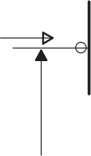
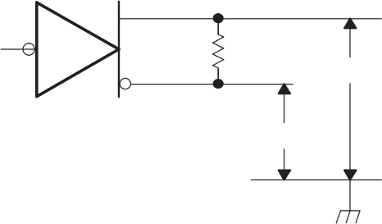
II
D
b

VOD

IO

VI

0 V or 3 V 60 Ω
CANH
CANL
Figure 18. Driver Voltage and Current Definitions

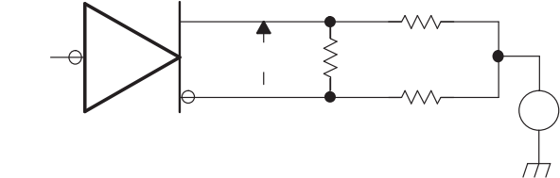
0 V
167 Ω

60 Ω
167 Ω
± –2 V ≤ V TEST ≤ 7 V
VOD
Figure 19. Driver VOD

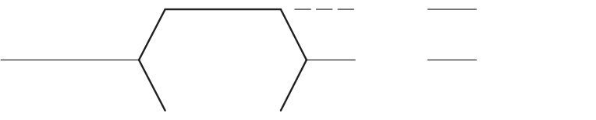

CANL ≈ 1 V VOH CANL
Recessive
≈ 2.3 V
Dominant CANH
≈ 3 V V OH
CANH
VOL
Figure 20. Driver Output Voltage Definitions

SN65HVD230, SN65HVD231, SN65HVD232
SLOS346O –MARCH 2001 –REVISED APRIL 2018 www.ti.com
Parameter Measurement Information (continued)
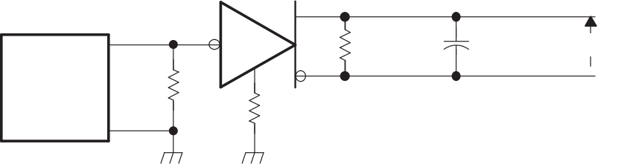
RL = 60 Ω
50 Ω
RS = 0 Ω to 100 kΩ for SN65HVD230 and SN65HVD231 N/A for SN65HVD232
Signal
Generator (see Note A)
CL = 50 pF (see Note B)
VO

3 V
1.5 V
0 V tPHL
90%
0.9 V
0.5 V
10%
Input

Output
VOD(D)

VOD(R)
tr t f
tPLH
A. The input pulse is supplied by a generator having the following characteristics: PRR ≤ 500 kHz, 50% duty cycle, tr ≤ 6 ns, tf ≤ 6 ns, Zo = 50 Ω .
B. CL includes probe and jig capacitance.
Figure 21. Driver Test Circuit and Voltage Waveforms

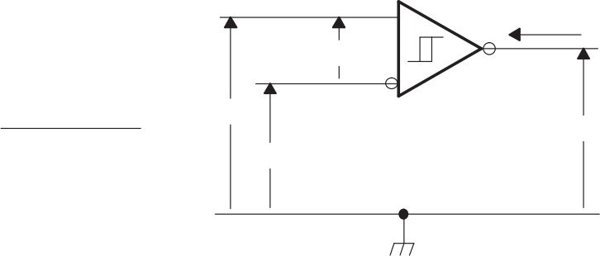
IO VID
VCANH
VCANL
VCANH + VCANL
2
VIC =
VO
Figure 22. Receiver Voltage and Current Definitions

SN65HVD230, SN65HVD231, SN65HVD232 www.ti.com SLOS346O –MARCH 2001 –REVISED APRIL 2018
Parameter Measurement Information (continued)
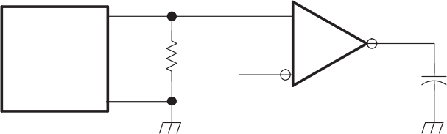
Output

1.5 V
Signal
Generator (see Note A)
CL = 15 pF (see Note B)
50 Ω

90%
Output 1.3 V
10% tr t f
Input

tPLH t PHL
2.9 V
2.2 V
1.5 V
V OH

VOL
A. The input pulse is supplied by a generator having the following characteristics: PRR ≤ 500 kHz, 50% duty cycle, tr ≤ 6 ns, tf ≤ 6 ns, Zo = 50 Ω .
B. CL includes probe and jig capacitance.
Figure 23. Receiver Test Circuit and Voltage Waveforms

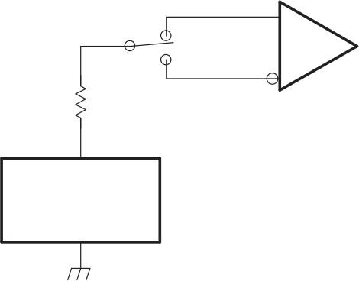
Pulse Generator,
15 μs Duration,
1% Duty Cycle
100 Ω
Figure 24. Overvoltage Protection

SN65HVD230, SN65HVD231, SN65HVD232
SLOS346O –MARCH 2001 –REVISED APRIL 2018 www.ti.com
Parameter Measurement Information (continued)
Table 1. Receiver Characteristics Over Common Mode With V(Rs) = 1.2 V

VIC | VID | VCANH | VCANL | R OUTPUT
-2 V | 900 mV | -1.55 V | -2.45 V | L | VOL
7 V | 900 mV | 8.45 V | 6.55 V | L | VOL
1 V | 6 V | 4 V | -2 V | L | VOL
4 V | 6 V | 7 V | 1 V | L | VOL
-2 V | 500 mV | -1.75 V | -2.25 V | H | V OH
7 V | 500 mV | 7.25 V | 6.75 V | H | V OH
1 V | -6 V | -2 V | 4 V | H | V OH
4 V | -6 V | 1 V | 7 V | H | V OH
X | X | Open | Open | H | V OH
CL = 15 pF
V CC
60 Ω <
O
0 V
Output
10 kΩ
D
R

RS

+
50 Ω V(Rs) –
Generator
PRR = 150 kHz
50% Duty Cycle
tr, t f < 6 ns
Zo = 50 Ω
Signal
Generator

R Output
V CC
V(Rs) 1.5 V
0 V
t(WAKE)
1.3 V
Figure 25. t(WAKE) Test Circuit and Voltage Waveforms

SN65HVD230, SN65HVD231, SN65HVD232
www.ti.com SLOS346O –MARCH 2001 –REVISED APRIL 2018

0 Ω, 10 kΩ or
100 kΩ ±5%
RS
CANH
D
60 Ω ±1%
VI
CANL
R
+
15 pF ±20%
VO

DUT
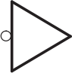
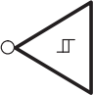

VI 50% 50%
t(LOOP1)
t(LOOP2)

50%f
50% +
VO

V CC

0 V

V OH

VOL

A. All VI input pulses are supplied by a generator having the following characteristics: tr or tf ≤ 6 ns, Pulse Repetition Rate (PRR) = 125 kHz, 50% duty cycle.
Figure 26. t(LOOP) Test Circuit and Voltage Waveforms

SN65HVD230, SN65HVD231, SN65HVD232
SLOS346O –MARCH 2001 –REVISED APRIL 2018 www.ti.com

CANH and CANL Inputs

Input
16 V 110 kΩ 9 kΩ

45 kΩ

20 V 9 kΩ
V CC

D Input

V CC
100 kΩ
1 kΩ Input

9 V

CANH and CANL Outputs

V CC
V CC

16 V

Output

20 V

R Output

5 Ω
Output

9 V

Figure 27. Equivalent Input and Output Schematic Diagrams

SN65HVD230, SN65HVD231, SN65HVD232
www.ti.com SLOS346O –MARCH 2001 –REVISED APRIL 2018

10 Detailed Description

10.1 Overview
ISO 11898 family of standards are the international standard for high speed serial communication using the controller area network (CAN) bus protocol and physical layers (transceivers). It supports multimaster operation, real time control, programmable data rates up to 1 Mbps, and powerful redundant error checking procedures that provide reliable data transmission. It is suited for networking intelligent devices as well as sensors and actuators within the rugged electrical environment of a machine chassis or factory floor. The SN65HVD23x family of 3.3 V CAN transceivers implement the lowest layers of the ISO/OSI reference model, the ISO11898-2 standard. This is the interface with the physical signaling output of the CAN controller of the Texas Instruments µPs, MCUs and DSPs, such as TMS320Lx240x 3.3 V DSPs, as illustrated in Figure 28.

Implementation

TMS320Lx2403/6/7
3.3-V
DSP
Embedded
CAN
Controller
SN65HVD230
CAN Bus-Line

ISO 11898 Specification

Application Specific Layer
Data-Link  Layer | Logic Link Control
Data-Link  Layer | Medium Access Control
Physical  Layer | Physical Signaling
Physical  Layer | Physical Medium Attachment
Physical  Layer | Medium Dependent Interface

Figure 28. Layered ISO 11898 Standard Architecture

10.2 Functional Block Diagram
SN65HVD232
Logic Diagram (Positive Logic)
1
D
7
CANH CANL
4
R
6
SN65HVD230, SN65HVD231 Logic Diagram (Positive Logic)
Vref

CANH
CANL
V CC

D
RS
R
5

7
6
3

1
8

4
Figure 29. Logic Diagram (Positive Logic)

SN65HVD230, SN65HVD231, SN65HVD232
SLOS346O –MARCH 2001 –REVISED APRIL 2018

www.ti.com

10.3 Feature Description
The SN65HVD230/231/232 are pin-compatible (but not functionally identical) with one another and, depending upon the application, may be used with identical circuit boards.
These transceivers feature single 3.3 V supply operation and standard compatibility with signaling rates up to 1 Mbps, ± 16 kV HBM ESD protection on the bus pins, thermal shutdown protection, bus fault protection, and open- circuit receiver failsafe. The fail-safe design of the receiver assures a logic high at the receiver output if the bus wires become open circuited.
The bus pins are also maintained in a high-impedance state during low VCC conditions to ensure glitch-free power-up and power-down bus protection for hot-plugging applications. This high-impedance condition also means that an unpowered node does not disturb the bus. Transceivers without this feature usually have a very low output impedance. This results in a high current demand when the transceiver is unpowered, a condition that could affect the entire bus.

10.3.1 Vref Voltage Reference
The Vref pin (pin 5) on the SN65HVD230 and SN65HVD231 is available as a VCC/2 voltage reference. This pin can be connected to the common mode point of a split termination to help further stabilize the common mode voltage of the bus. If the Vref pin is not used it may be left floating.

10.3.2 Thermal Shutdown
If a high ambient temperature or excessive output currents result in thermal shutdown, the driver will be disabled and the bus pins become high impedance. During thermal shutdown the D pin to bus transmission path is blocked and the CAN bus pins are high impedance and biased to a recessive level. Once the thermal shutdown condition is cleared and the junction temperature drops below the thermal shutdown temperature the driver will be reactivated and resume normal operation. During a thermal shutdown the receiver to R pin path remains operational.

10.4 Device Functional Modes
The RS pin (Pin 8) of the SN65HVD230 and SN65HVD231 provides three different modes of operation: high- speed mode, slope-control mode, and low-power mode.

10.4.1 High-Speed Mode
The high-speed mode can be selected by applying a logic low to the RS pin (pin 8). The high-speed mode of operation is commonly employed in industrial applications. High-speed allows the output to switch as fast as possible with no internal limitation on the output rise and fall slopes. If the high speed transitions are a concern for emissions performance slope control mode can be used.
If both high speed mode and the low-power standby mode is to be used in the application, direct connection to a µP, MCU or DSP general purpose output pin can be used to switch between a logic-low level (< 1.2 V) for high speed operation, and the logic-high level (> 0.75 VCC) for standby. Figure 30 shows a typical DSP connection, and Figure 31 shows the HVD230 driver output signal in high-speed mode on the CAN bus.
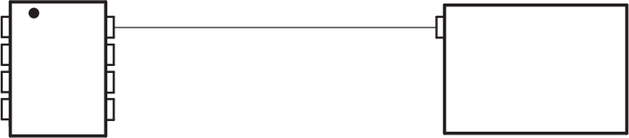
IOPF6
TMS320LF2406
or
TMS320LF2407
RS
CANH
CANL
Vref
D
GND
V CC
R
8
7
6
5
1
2
3
4
Figure 30. RS (Pin 8) Connection to a TMS320LF2406/07 for High Speed/Standby Operation

SN65HVD230, SN65HVD231, SN65HVD232
www.ti.com SLOS346O –MARCH 2001 –REVISED APRIL 2018 Device Functional Modes (continued)
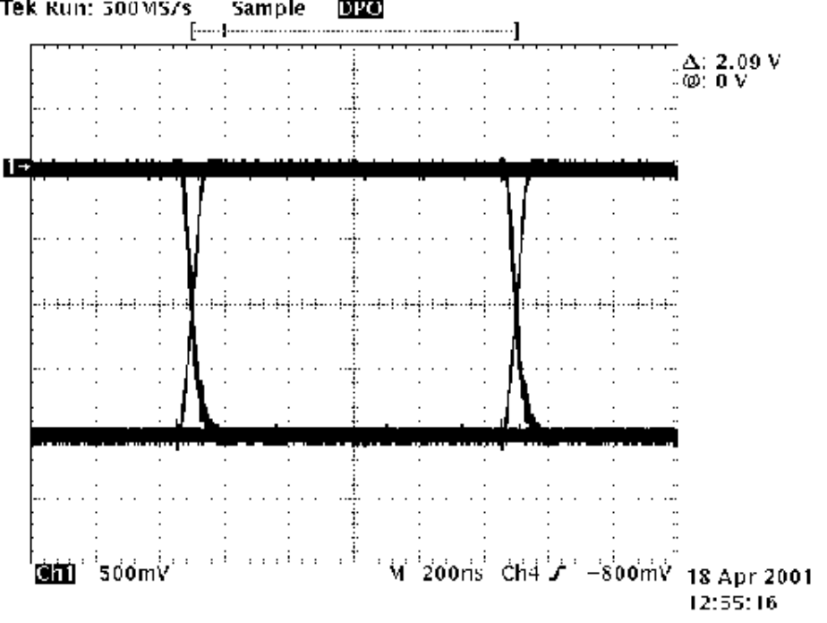

1 Mbps
Driver Output
NRZ Data

1
Figure 31. Typical High Speed SN65HVD230 Output Waveform into a 60-Ω Load

10.4.2 Slope Control Mode
Electromagnetic compatibility is essential in many applications while still making use of unshielded twisted pair bus cable to reduce system cost. Slope control mode was added to the SN65HVD230 and SN65HVD231 devices to reduce the electromagnetic interference produced by the rise and fall times of the driver and resulting harmonics. These rise and fall slopes of the driver outputs can be adjusted by connecting a resistor from RS (pin 8) to ground or to a logic low voltage, as shown in Figure 32. The slope of the driver output signal is proportional to the pin's output current. This slope control is implemented with an external resistor value of 10 kΩ to achieve a ~15 V/μs slew rate, and up to 100 kΩ to achieve a ~2.0 V/μs slew rate as displayed in Figure 33.
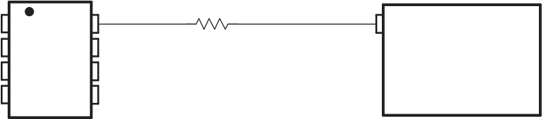
IOPF6
TMS320LF2406
or
TMS320LF2407
RS 100 kΩ
CANH
CANL
Vref
D
GND
V CC
R
8
7
6
5
1
2
3
4
10 kΩ
to
Figure 32. Slope Control/Standby Connection to a DSP

SN65HVD230, SN65HVD231, SN65HVD232
SLOS346O –MARCH 2001 –REVISED APRIL 2018

www.ti.com

Device Functional Modes (continued)

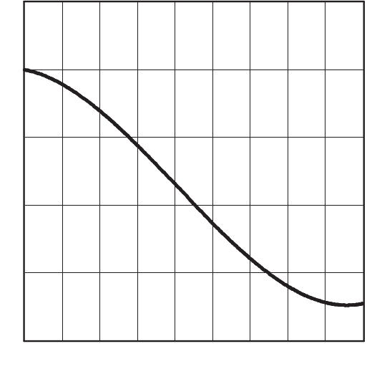
Driver Outout Signa l Slope – V/μs
0
0 .07 0.8 0 2520 00
Slope Control Resistance – kΩ
25

20

15

10

5
Figure 33. HVD230 Driver Output Signal Slope vs Slope Control Resistance Value

10.4.3 Standby Mode (Listen Only Mode) of the HVD230
If a logic high (> 0.75 VCC) is applied to RS (pin 8) in Figure 30 and Figure 32, the circuit of the SN65HVD230 enters a low-current, listen only standby mode, during which the driver is switched off and the receiver remains active. In this listen only state, the transceiver is completely passive to the bus. It makes no difference if a slope control resistor is in place as shown in Figure 32. The µP can reverse this low-power standby mode when the rising edge of a dominant state (bus differential voltage > 900 mV typical) occurs on the bus. The µP, sensing bus activity, reactivates the driver circuit by placing a logic low (< 1.2 V) on RS (pin 8).

10.4.4 The Babbling Idiot Protection of the HVD230
Occasionally, a runaway CAN controller unintentionally sends messages that completely tie up the bus (what is referred to in CAN jargon as a babbling idiot). When this occurs, the µP, MCU or DSP can engage the listen-only standby mode of the transceiver to disable the driver and release the bus, even when access to the CAN controller has been lost. When the driver circuit is deactivated, its outputs default to a high-impedance state (recessive).

10.4.5 Sleep Mode of the HVD231
The unique difference between the SN65HVD230 and the SN65HVD231 is that both driver and receiver are switched off in the SN65HVD231 when a logic high is applied to RS (pin 8). The device remains in a very low power-sleep mode until the circuit is reactivated with a logic low applied to RS (pin 8). While in this sleep mode, the bus-pins are in a high-impedance state, while the D and R pins default to a logic high.

10.4.6 Summary of Device Operating Modes
Table 2 shows a summary of the operating modes for the SN65HVD230 and SN65HVD231. Please note that the SN65HVD232 is a basic CAN transceiver has only the normal high speed mode of operation; pins 5 and 8 are no connection (NC).

SN65HVD230, SN65HVD231, SN65HVD232
www.ti.com SLOS346O –MARCH 2001 –REVISED APRIL 2018
Device Functional Modes (continued)
Table 2. SN65HVD230 and SN65HVD231 Operating Modes

R S Pin | MODE |  | DRIVER | RECEIVER | RXD Pin
LOW, V(Rs) < 1.2 V, strong pull down to GND | High Speed Mode |  | Enabled (ON) High Speed | Enabled (ON) | Mirrors Bus State(1)
LOW, V(Rs) < 1.2 V, 10 kΩ  to 100 kΩ pull down to  GND | Slope Control Mode |  | Enabled (ON) with Slope Control | Enabled (ON) | Mirrors Bus State
HIGH, V(Rs) > 0.75 V CC | Low Current  Mode | SN65HVD230: Standby Mode | Disabled (OFF) | Enabled (ON) | Mirrors Bus State
HIGH, V(Rs) > 0.75 V CC | Low Current  Mode | SN65HVD231: Sleep Mode | Disabled (OFF) | Disabled (OFF) | High
(1) Mirrors bus state: low if CAN bus is dominant, high if CAN bus is recessive.
Table 3. SN65HVD230 and SN65HVD231 Driver Functions

DRIVER (SN65HVD230, SN65HVD231)(1)
INPUT D | RS | OUTPUTS |  | BUS STATE
INPUT D | RS | CANH | CANL | BUS STATE
L | V(Rs) < 1.2 V (including 10  kΩ to 100 kΩ pull down to  GND) | H | L | Dominant
H | V(Rs) < 1.2 V (including 10  kΩ to 100 kΩ pull down to  GND) | Z | Z | Recessive
Open | X | Z | Z | Recessive
X | V(Rs) > 0.75 V CC | Z | Z | Recessive
(1) H = high level; L = low level; X = irrelevant; ? = indeterminate; Z = high impedance
Table 4. SN65HVD230 Receiver Functions

RECEIVER (SN65HVD230)(1)
DIFFERENTIAL INPUTS | RS | OUTPUT R
VID ≥ 0.9 V | X | L
0.5 V < VID < 0.9 V | X | ?
VID ≤ 0.5 V | X | H
Open | X | H
(1) H = high level; L = low level; X = irrelevant; ? = indeterminate
Table 5. SN65HVD231 Receiver Functions

RECEIVER (SN65HVD231)(1)
DIFFERENTIAL INPUTS | RS | OUTPUT R
VID ≥ 0.9 V | V(Rs) < 1.2 V (including 10 kΩ to 100 kΩ pull  down to GND) | L
0.5 V < VID < 0.9 V | V(Rs) < 1.2 V (including 10 kΩ to 100 kΩ pull  down to GND) | ?
VID ≤ 0.5 V | V(Rs) < 1.2 V (including 10 kΩ to 100 kΩ pull  down to GND) | H
X | V(Rs) > 0.75 V CC | H
X | 1.2 V < V(Rs) < 0.75 V CC | ?
Open | X | H
(1) H = high level; L = low level; X = irrelevant; ? = indeterminate

SN65HVD230, SN65HVD231, SN65HVD232
SLOS346O –MARCH 2001 –REVISED APRIL 2018 www.ti.com
Table 6. SN65HVD232 Receiver Functions

RECEIVER (SN65HVD232)(1)
DIFFERENTIAL INPUTS | OUTPUT R
VID ≥ 0.9 V | L
0.5 V < VID < 0.9 V | ?
VID ≤ 0.5 V | H
Open | H
(1) H = high level; L = low level; X = irrelevant; ? = indeterminate
Table 7. SN65HVD232 Driver Functions

DRIVER (SN65HVD232)(1)
INPUT D | OUTPUTS |  | BUS STATE
INPUT D | CANH | CANL | BUS STATE
L | H | L | Dominant
H | Z | Z | Recessive
Open | Z | Z | Recessive
(1) H = high level; L = low level; Z = high impedance

SN65HVD230, SN65HVD231, SN65HVD232
www.ti.com SLOS346O –MARCH 2001 –REVISED APRIL 2018

11 Application and Implementation
NOTE
Information in the following applications sections is not part of the TI component specification, and TI does not warrant its accuracy or completeness. TI’s customers are responsible for determining suitability of components for their purposes. Customers should validate and test their design implementation to confirm system functionality.

11.1 Application Information
This application section provides information concerning the implementation of the physical medium attachment layer in a CAN network according to the ISO 11898 standard. It presents a typical application circuit and test results, as well as discussions on slope control, total loop delay, and interoperability in 5-V CAN systems.

11.1.1 CAN Bus States
The CAN bus has two states during powered operation of the device; dominant and recessive. A dominant bus state is when the bus is driven differentially, corresponding to a logic low on the D and R pin. A recessive bus state is when the bus is biased to VCC / 2 via the high-resistance internal resistors RI and RDiff of the receiver, corresponding to a logic high on the D and R pins. See Figure 34 and Figure 35.

▲
1 2 3 4
Typica l Bus Vo ltage (V)
CANH
▲

Vdiff(D)
Vdiff(R)
CANL

Dominant Logic L
Recessive Logic H
Recessive Logic H

Time, t

Figure 34. CAN Bus States (Physical Bit Representation)

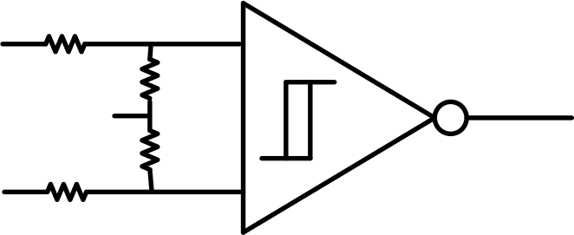
CANH

RXD VCC/2
CANL
Figure 35. Simplified Recessive Common Mode Bias and Receiver

SN65HVD230, SN65HVD231, SN65HVD232
SLOS346O –MARCH 2001 –REVISED APRIL 2018

www.ti.com

11.2 Typical Application
Figure 36 illustrates a typical application of the SN65HVD23x family. The output of the host µP's CAN controller (TXD) is connected to the transceivers driver input, pin D, and the transceivers receiver output, pin R, is connected to the input of the CAN controller (RXD). The transceiver is attached to the differential bus lines at pins CANH and CANL. Typically, the bus is a twisted pair of wires with a characteristic impedance of 120 Ω , in the standard half-duplex multipoint topology of Figure 37. Each end of the bus is terminated with 120 Ω resistors in compliance with the standard to minimize signal reflections on the bus.
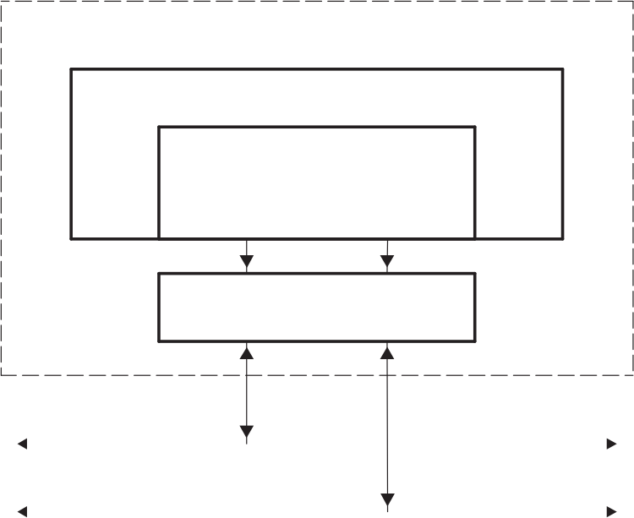
CANTX/IOPC6 CANRX/IOPC7

D R
SN65HVD230

CANH CANL

CAN Bus Line
Electronic Control Unit (ECU)

TMS320Lx2403/6/7

CAN-Controller
Figure 36. Details of a Typical CAN Node

CAN Bus Line
CANL
120 Ω
120 Ω
ECU ECU ECU
1 2 n
CANH
Figure 37. Typical CAN Network

11.2.1 Design Requirements

11.2.1.1 CAN Termination
The ISO11898 standard specifies the interconnect to be a single twisted pair cable (shielded or unshielded) with 120 Ω characteristic impedance (ZO). Resistors equal to the characteristic impedance of the line should be used to terminate both ends of the cable to prevent signal reflections. Unterminated drop lines (stubs) connecting nodes to the bus should be kept as short as possible to minimize signal reflections. The termination may be on the cable or in a node, but if nodes may be removed from the bus the termination must be carefully placed so that it is not removed from the bus.

SN65HVD230, SN65HVD231, SN65HVD232
www.ti.com SLOS346O –MARCH 2001 –REVISED APRIL 2018
Typical Application (continued)

Node n
(with termination)
MCU or DSP

CAN
Controller

CAN
Transceiver
RTERM
Node 1
MCU or DSP

CAN
Controller

CAN
Transceiver
Node 2
MCU or DSP

CAN
Controller

CAN
Transceiver
Node 3
MCU or DSP

CAN
Controller

CAN
Transceiver
RTERM
Figure 38. Typical CAN Bus
Termination is typically a 120 Ω resistor at each end of the bus. If filtering and stabilization of the common mode voltage of the bus is desired, then split termination may be used (see Figure 39). Split termination utilizes two 60Ω resistors with a capacitor in the middle of these resistors to ground. Split termination improves the electromagnetic emissions behavior of the network by eliminating fluctuations in the bus common mode voltages at the start and end of message transmissions.
Care should be taken in the power ratings of the termination resistors used. Typically the worst case condition would be if the system power supply was shorted across the termination resistance to ground. In most cases the current flow through the resistor in this condition would be much higher than the transceiver's current limit.
Standard Termination
CANH 回 ● m
CAN
Transceiver RTERM
CANL
RTERM/2

CSPLIT RTERM/2
CANH

CAN
Transceiver

CANL
Split Termination
Figure 39. CAN Bus Termination Concepts

11.2.1.2 Loop Propagation Delay
Transceiver loop delay is a measure of the overall device propagation delay, consisting of the delay from the driver input (D pin) to the differential outputs (CANH and CANL pins), plus the delay from the receiver inputs (CANH and CANL) to its output (R pin).

SN65HVD230, SN65HVD231, SN65HVD232
SLOS346O –MARCH 2001 –REVISED APRIL 2018

www.ti.com

Typical Application (continued)
A typical loop delay for the SN65HVD230 transceiver is displayed in Figure 40. This loop delay will increase as the slope of the driver output is slowed during slope control mode. This increased loop delay means that there is a tradeoff between the total bus length able to be used and the driver's output slope used via the slope control pin of the device. For example, the loop delay for a 10-kΩ resistor from the RS pin to ground is ~100 ns, and the loop delay for a 100-kΩ resistor is ~500 ns. Therefore, if we use the following rule-of-thumb that the propagation delay of typical twisted pair bus cable is 5 ns/m, we can calculate an approximate cable length trade-off between normal high-speed mode and slope control mode with a 100-kΩ resistor. Using typical values, the loop delay for a recessive to dominant bit with RS tied directly to ground is 70ns, and with a 100-kΩ resistor is 535 ns. At 5ns/m of propagation delay, which you have to count in both directions the difference is 46.5 meters (535-70)/(2*5).
Another option to improving the elctromagnetic emissions of the device besides slowing down the edge rates of the driver in slope control mode is using quality shielded bus cabling.
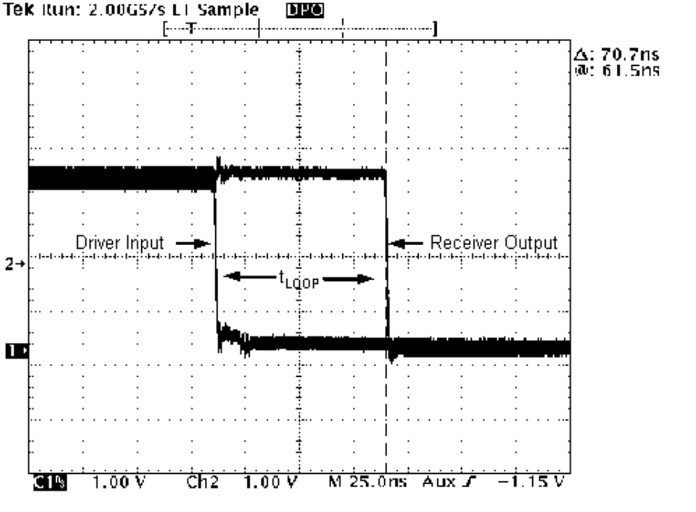
( )
Figure 40. 70.7-ns Loop Delay Through the HVD230 With RS = 0

11.2.1.3 Bus Loading, Length and Number of Nodes
The ISO11898 Standard specifies up to 1 Mbps data rate, maximum bus length of 40 meters, maximum drop line (stub) length of 0.3 meters and a maximum of 30 nodes. However, with careful network design, the system may have longer cables, longer stub lengths, and many more nodes. Many CAN organizations and standards have scaled the use of CAN for applications outside the original ISO11898 standard. They have made system level trade-offs for data rate, cable length, and parasitic loading of the bus. Examples of some of these specifications are ARINC825, CANopen, CAN Kingdom, DeviceNet and NMEA200.
A high number of nodes requires a transceiver with high input impedance and wide common mode range such as the SN65HVD23x CAN family. ISO11898-2 specifies the driver differential output with a 60 Ω load (two 120 Ω termination resistors in parallel) and the differential output must be greater than 1.5 V. The SN65HVD23x devices are specified to meet the 1.5 V requirement with a 60 Ω load, and additionally specified with a differential output voltage minimum of 1.2 V across a common mode range of –2 V to 7 V via a 167 Ω coupling network. This network represents the bus loading of 120 SN65HVD23x transceivers based on their minimum differential input resistance of 40 kΩ . Therefore, the SN65HVD23x supports up to 120 transceivers on a single bus segment with margin to the 1.2 V minimum differential input voltage requirement at each node. For CAN network design,

SN65HVD230, SN65HVD231, SN65HVD232
www.ti.com SLOS346O –MARCH 2001 –REVISED APRIL 2018 Typical Application (continued)
margin must be given for signal loss across the system and cabling, parasitic loadings, network imbalances, ground offsets and signal integrity thus a practical maximum number of nodes may be lower. Bus length may also be extended beyond the original ISO11898 standard of 40 meters by careful system design and data rate tradeoffs. For example, CANopen network design guidelines allow the network to be up to 1 km with changes in the termination resistance, cabling, less than 64 nodes and significantly lowered data rate.
This flexibility in CAN network design is one of the key strengths of the various extensions and additional standards that have been built on the original ISO11898 CAN standard. In using this flexibility comes the responsibility of good network design.

11.2.2 Detailed Design Procedure
The following system level considerations should be looked at when designing your application. There are trade- offs between the total number of nodes, the length of the bus, and the slope of the driver output that need to be evaluated when building up a system

11.2.2.1 Transient Protection
Typical applications that use CAN will sometime require some form of ESD, burst, or surge protection performance at the system level. If these requirements are higher than those of the device some form of external protection may be needed to shield the transceiver against these high power transients that can cause damage. Transient voltage suppressor (TVS) are very commonly used and can help clamp the amount of energy that reaches the transceiver.

11.2.2.2 Transient Voltage Suppressors
Transient voltage suppressors are the preferred protection components for CAN bus applications due to their low capacitance, fast response times and high peak power dissipation limits. The low bus capacitance allows these devices to be used at many, if not all, nodes on the network without having to reduce the data rate. The quick response times in the order of a few picoseconds enable these devices to clamp the energy of very fast transients like ESD and EFT. Lastly, the high peak power ratings enable these devices to handle high energy surge pulses without being damaged.

11.2.3 Application Curve
Typical driver output waveforms from a pulse input signal with different slope control resistances are displayed in Figure 41. The top waveform show the typical differential signal when transitioning from a recessive level to a dominant level on the CAN bus with RS tied to GND through a zero ohm resistor. The second waveform shows the same signal for the condition with a 10k ohm resistor tied from RS to ground. The bottom waveform shows the typical differential signal for the case where a 100k ohm resistor is tied from the RS pin to ground.

SN65HVD230, SN65HVD231, SN65HVD232
SLOS346O –MARCH 2001 –REVISED APRIL 2018

www.ti.com

Typical Application (continued)

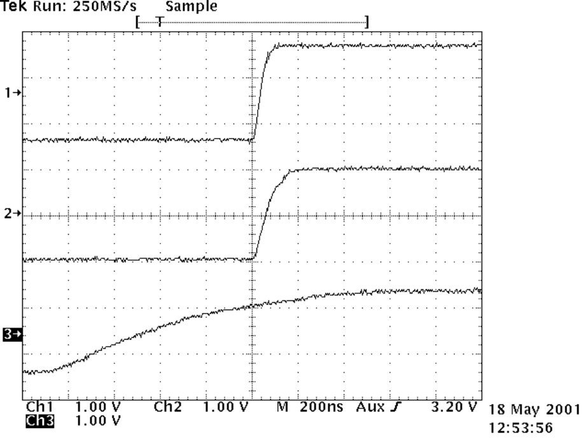
RS = 0 Ω

RS = 10 kΩ

RS = 100 kΩ

Figure 41. Typical SN65HVD230 250-kbps Output Pulse Waveforms With Slope Control

11.3 System Example

11.3.1 ISO 11898 Compliance of SN65HVD23x Family of 3.3 V CAN Transceivers

11.3.1.1 Introduction
Many users value the low power consumption of operating their CAN transceivers from a 3.3 V supply. However, some are concerned about the interoperability with 5 V supplied transceivers on the same bus. This report analyzes this situation to address those concerns.

11.3.1.2 Differential Signal
CAN is a differential bus where complementary signals are sent over two wires and the voltage difference between the two wires defines the logical state of the bus. The differential CAN receiver monitors this voltage difference and outputs the bus state with a single-ended output signal.

SN65HVD230, SN65HVD231, SN65HVD232
www.ti.com SLOS346O –MARCH 2001 –REVISED APRIL 2018
System Example (continued)

NOISE MARGIN

900
500
mV Threshold
mV Threshold
75% SAMPLE POINT

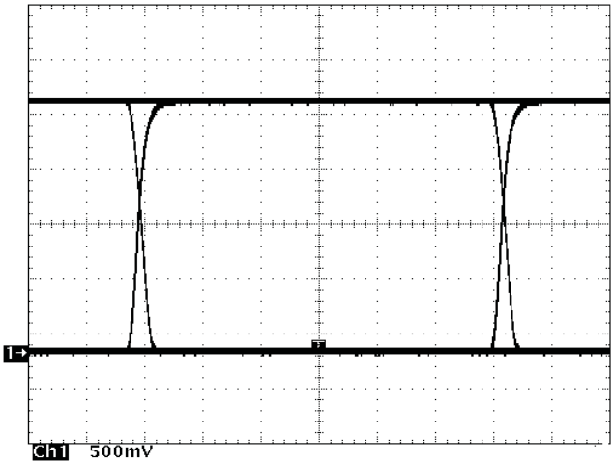
RECEIVER DETECTION WINDOW
NOISE MARGIN

Figure 42. Typical SN65HVD230 Differential Output Voltage Waveform
The CAN driver creates the differential voltage between CANH and CANL in the dominant state. The dominant differential output of the SN65HVD23x is greater than 1.5 V and less than 3 V across a 60 ohm load as defined by the ISO 11898 standard. These are the same limiting values for 5 V supplied CAN transceivers. Typically, the bus termination resistors drive the bus back to the recessive bus state and not the CAN driver.
A CAN receiver is required to output a recessive state when less than 500 mV of differential voltage exists on the bus, and a dominant state when more than 900 mV of differential voltage exists on the bus. The CAN receiver must do this with common-mode input voltages from -2 V to 7 volts per the ISO 11898-2 standard. The SN65HVD23x family receivers meet these same input specifications as 5 V supplied receivers.
11.3.1.2.1 Common Mode Signal
A common-mode signal is an average voltage of the two signal wires that the differential receiver rejects. The common-mode signal comes from the CAN driver, ground noise, and coupled bus noise. Since the bias voltage of the recessive state of the device is dependent on VCC, any noise present or variation of VCC will have an effect on this bias voltage seen by the bus. The SN65HVD23x family has the recessive bias voltage set higher than 0.5*VCC to comply with the ISO 11898-2 CAN standard which states that the recessive bias voltage must be between 2 V and 3 V. The caveat to this is that the common mode voltage will drop by a couple hundred millivolts when driving a dominant bit on the bus. This means that there is a common mode shift between the dominant bit and recessive bit states of the device. While this is not ideal, this small variation in the driver common-mode output is rejected by differential receivers and does not effect data, signal noise margins or error rates.

11.3.1.3 Interoperability of 3.3-V CAN in 5-V CAN Systems
The 3.3 V supplied SN65HVD23x family of CAN transceivers are fully compatible with 5 V CAN transceivers. The differential output voltage is the same, the recessive common mode output bias is the same, and the receivers have the same input specifications. The only difference is in the dominant common mode output voltage is lower in 3.3 V CAN transceivers than with 5 V supplied transceiver (by a few hundred millivolts).
To help ensure the widest interoperability possible, the SN65HVD23x family has successfully passed the internationally recognized GIFT ICT conformance and interoperability testing for CAN transceivers which is shown in . Electrical interoperability does not always assure interchangeability however. Most implementers of CAN buses recognize that ISO 11898 does not sufficiently specify the electrical layer and that strict standard compliance alone does not ensure full interchangeability. This comes only with thorough equipment testing.

SN65HVD230, SN65HVD231, SN65HVD232
SLOS346O –MARCH 2001 –REVISED APRIL 2018

www.ti.com

System Example (continued)

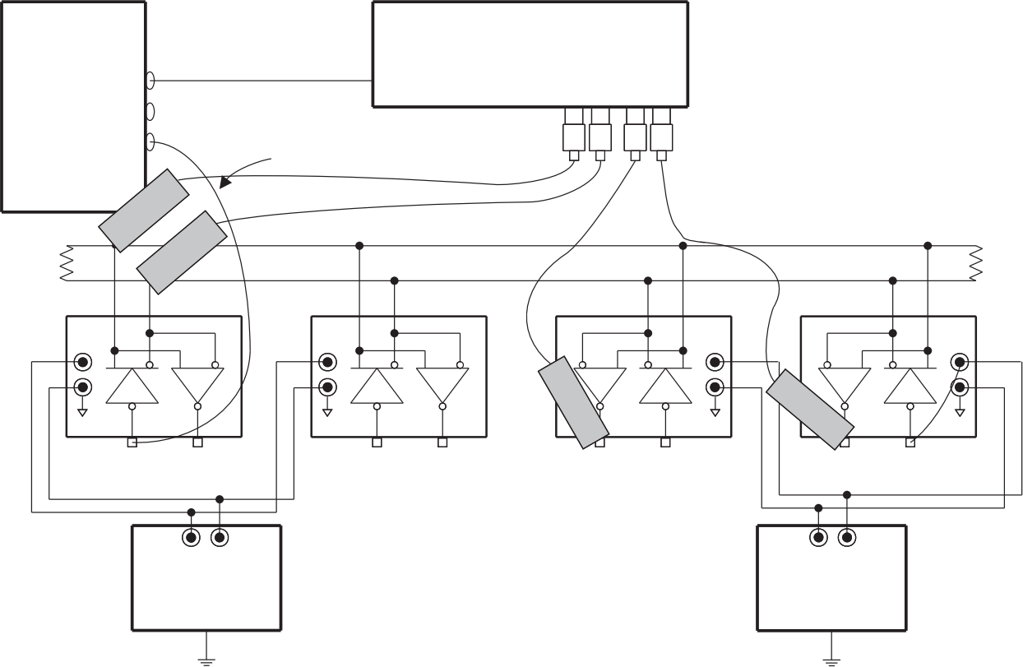
One Meter Belden Cable # 3105A
120 Ω 120 Ω

SN65HVD230 SN65HVD230 SN65HVD251 Competitor X251
Trigger Input
TEKTRONIX P6243
Single-Ended Probes
TEKTRONIX
HFS-9003
Pattern
Generator
– +
HP E3516A
3.3-V Power
Supply
– +
HP E3516A
5-V Power
Supply
TEKTRONIX 784D
Oscilloscope
Figure 43. 3.3-V and 5-V CAN Transceiver System Testing

12 Power Supply Recommendations
The SN65HVD23x 3.3 V CAN transceivers provide the interface between the 3.3 V µPs, MCUs and DSPs and the differential bus lines, and are designed to transmit data at signaling rates up to 1 Mbps as defined by the ISO 11898 standard.
To ensure reliable operation at all data rates and supply voltages, the VCC supply pin of each CAN transceiver should be decoupled with a 100-nF ceramic capacitor located as close to the VCC and GND pins as possible. The TPS76333 is a linear voltage regulator suitable for supplying the 3.3-V supply.

SN65HVD230, SN65HVD231, SN65HVD232 www.ti.com SLOS346O –MARCH 2001 –REVISED APRIL 2018

13 Layout

13.1 Layout Guidelines
In order for the PCB design to be successful, start with design of the protection and filtering circuitry. Because ESD and EFT transients have a wide frequency bandwidth from approximately 3 MHz to 3 GHz, high frequency layout techniques must be applied during PCB design. On chip IEC ESD protection is good for laboratory and portable equipment but is usually not sufficient for EFT and surge transients occurring in industrial environments. Therefore robust and reliable bus node design requires the use of external transient protection devices at the bus connectors. Placement at the connector also prevents these harsh transient events from propagating further into the PCB and system.
Use VCC and ground planes to provide low inductance. Note: high frequency current follows the path of least inductance and not the path of least resistance.
Design the bus protection components in the direction of the signal path. Do not force the transient current to divert from the signal path to reach the protection device.
An example placement of the Transient Voltage Suppression (TVS) device indicated as D1 (either bi-directional diode or varistor solution) and bus filter capacitors C8 and C9 are shown in .
The bus transient protection and filtering components should be placed as close to the bus connector, J1, as possible. This prevents transients, ESD and noise from penetrating onto the board and disturbing other devices. Bus termination: Figure 44 shows split termination. This is where the termination is split into two resistors, R7 and R8, with the center or split tap of the termination connected to ground via capacitor C7. Split termination provides common mode filtering for the bus. When termination is placed on the board instead of directly on the bus, care must be taken to ensure the terminating node is not removed from the bus as this will cause signal integrity issues of the bus is not properly terminated on both ends. See the application section for information on power ratings needed for the termination resistor(s).
Bypass and bulk capacitors should be placed as close as possible to the supply pins of transceiver, examples C2, C3 (VCC).
Use at least two vias for VCC and ground connections of bypass capacitors and protection devices to minimize trace and via inductance.
To limit current of digital lines, serial resistors may be used. Examples are R1, R2, R3 and R4.
To filter noise on the digital IO lines, a capacitor may be used close to the input side of the IO as shown by C1 and C4.
Since the internal pull up and pull down biasing of the device is weak for floating pins, an external 1k to 10k ohm pull-up or down resistor should be used to bias the state of the pin more strongly against noise during transient events.
Pin 1: If an open drain host processor is used to drive the D pin of the device an external pull-up resistor between 1k and 10k ohms should be used to drive the recessive input state of the device (R1).
Pin 8: is shown assuming the mode pin, RS, will be used. If the device will only be used in normal mode or slope control mode, R3 is not needed and the pads of C4 could be used for the pull down resistor to GND.
Pin 5 in is shown for the SN65HVD230 and SN65HVD231 devices which have a Vref output voltage reference. If used, this pin should be tied to the common mode point of the split termination. If this feature is not used, the pin can be left floating.
For the SN65HVD232, pins 5 and 8 are no connect (NC) pin. This means that the pins are not internally connected and can be left floating.

SN65HVD230, SN65HVD231, SN65HVD232
SLOS346O –MARCH 2001 –REVISED APRIL 2018

www.ti.com

13.2 Layout Example

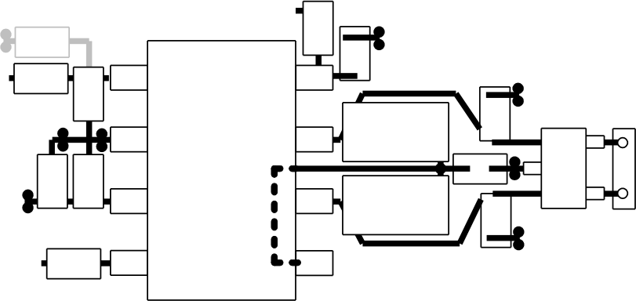
C2
C1
C3
R4
C4
C8
C9
D1
J1
R7

R8

Vref can be routed under the device
RS

U1
VCC R1
TXD R2
GND

VCC
RXD R3
GND
GND
GND
C7
Figure 44. SN65HVD23x Board Layout

SN65HVD230, SN65HVD231, SN65HVD232
www.ti.com SLOS346O –MARCH 2001 –REVISED APRIL 2018

14 Device and Documentation Support

14.1 Related Links
The table below lists quick access links. Categories include technical documents, support and community resources, tools and software, and quick access to sample or buy.
Table 8. Related Links

PARTS | PRODUCT FOLDER | SAMPLE & BUY | TECHNICAL DOCUMENTS | TOOLS & SOFTWARE | SUPPORT & COMMUNITY
SN65HVD230 | Click here | Click here | Click here | Click here | Click here
SN65HVD231 | Click here | Click here | Click here | Click here | Click here
SN65HVD232 | Click here | Click here | Click here | Click here | Click here

14.2 Receiving Notification of Documentation Updates
To receive notification of documentation updates, navigate to the device product folder on ti.com. In the upper right corner, click on Alert me to register and receive a weekly digest of any product information that has changed. For change details, review the revision history included in any revised document.

14.3 Community Resources
The following links connect to TI community resources. Linked contents are provided "AS IS" by the respective contributors. They do not constitute TI specifications and do not necessarily reflect TI's views; see TI's Terms of Use.
TI E2E™ Online Community TI's Engineer.to.Engineer (E2E) Community. Created to foster collaboration among engineers. At e2e.ti.com, you can ask questions, share knowledge, explore ideas and help solve problems with fellow engineers.
Design Support TI's Design Support Quickly find helpful E2E forums along with design support tools and contact information for technical support.

14.4 Trademarks
E2E is a trademark of Texas Instruments.
All other trademarks are the property of their respective owners.


14.5 Electrostatic Discharge Caution
These devices have limited built-in ESD protection. The leads should be shorted together or the device placed in conductive foam during storage or handling to prevent electrostatic damage to the MOS gates.

14.6 Glossary
SLYZ022 — TI Glossary.
This glossary lists and explains terms, acronyms, and definitions.

15 Mechanical, Packaging, and Orderable Information
The following pages include mechanical, packaging, and orderable information. This information is the most current data available for the designated devices. This data is subject to change without notice and revision of this document. For browser-based versions of this data sheet, refer to the left-hand navigation.

 PACKAGE OPTION ADDENDUM
www.ti.com 5-Mar-2026

PACKAGING INFORMATION

Orderable part number | Status  (1) | Material type  (2) | Package | Pins | Package qty | Carrier | RoHS  (3) | Lead finish/  Ball material  (4) | MSL rating/ Peak reflow  (5) | Op temp (°C) | Part marking  (6)
SN65HVD230D | Obsolete | Production | SOIC (D) | 8 | - | - | Call TI | Call TI | -40 to 85 | VP230
SN65HVD230DR | Active | Production | SOIC (D) | 8 | 2500 | LARGE T&R | Yes | NIPDAU | Level-1-260C-UNLIM | -40 to 85 | VP230
SN65HVD230DR.A | Active | Production | SOIC (D) | 8 | 2500 | LARGE T&R | Yes | NIPDAU | Level-1-260C-UNLIM | -40 to 85 | VP230
SN65HVD230DRG4 | Active | Production | SOIC (D) | 8 | 2500 | LARGE T&R | Yes | NIPDAU | Level-1-260C-UNLIM | -40 to 85 | VP230
SN65HVD231D | Obsolete | Production | SOIC (D) | 8 | - | - | Call TI | Call TI | -40 to 85 | VP231
SN65HVD231DR | Active | Production | SOIC (D) | 8 | 2500 | LARGE T&R | Yes | NIPDAU | Level-1-260C-UNLIM | -40 to 85 | VP231
SN65HVD231DR.A | Active | Production | SOIC (D) | 8 | 2500 | LARGE T&R | Yes | NIPDAU | Level-1-260C-UNLIM | -40 to 85 | VP231
SN65HVD231DRG4 | Active | Production | SOIC (D) | 8 | 2500 | LARGE T&R | Yes | NIPDAU | Level-1-260C-UNLIM | -40 to 85 | VP231
SN65HVD232D | Obsolete | Production | SOIC (D) | 8 | - | - | Call TI | Call TI | -40 to 85 | VP232
SN65HVD232DR | Active | Production | SOIC (D) | 8 | 2500 | LARGE T&R | Yes | NIPDAU | Level-1-260C-UNLIM | -40 to 85 | VP232
SN65HVD232DR.A | Active | Production | SOIC (D) | 8 | 2500 | LARGE T&R | Yes | NIPDAU | Level-1-260C-UNLIM | -40 to 85 | VP232
SN65HVD232DRG4 | Active | Production | SOIC (D) | 8 | 2500 | LARGE T&R | Yes | NIPDAU | Level-1-260C-UNLIM | -40 to 85 | VP232
(1) Status: For more details on status, see our product life cycle.
(2) Material type: When designated, preproduction parts are prototypes/experimental devices, and are not yet approved or released for full production. Testing and final process, including without limitation quality assurance, reliability performance testing, and/or process qualification, may not yet be complete, and this item is subject to further changes or possible discontinuation. If available for ordering, purchases will be subject to an additional waiver at checkout, and are intended for early internal evaluation purposes only. These items are sold without warranties of any kind.
(3) RoHS values: Yes, No, RoHS Exempt. See the TI RoHS Statement for additional information and value definition.
(4) Lead finish/Ball material: Parts may have multiple material finish options. Finish options are separated by a vertical ruled line. Lead finish/Ball material values may wrap to two lines if the finish value exceeds the maximum column width.
(5) MSL rating/Peak reflow: The moisture sensitivity level ratings and peak solder (reflow) temperatures. In the event that a part has multiple moisture sensitivity ratings, only the lowest level per JEDEC standards is shown. Refer to the shipping label for the actual reflow temperature that will be used to mount the part to the printed circuit board.
(6) Part marking: There may be an additional marking, which relates to the logo, the lot trace code information, or the environmental category of the part.
Multiple part markings will be inside parentheses. Only one part marking contained in parentheses and separated by a "~" will appear on a part. If a line is indented then it is a continuation of the previous line and the two combined represent the entire part marking for that device.

PACKAGE OPTION ADDENDUM
www.ti.com 5-Mar-2026

Important Information and Disclaimer:The information provided on this page represents TI's knowledge and belief as of the date that it is provided. TI bases its knowledge and belief on information provided by third parties, and makes no representation or warranty as to the accuracy of such information. Efforts are underway to better integrate information from third parties. TI has taken and continues to take reasonable steps to provide representative and accurate information but may not have conducted destructive testing or chemical analysis on incoming materials and chemicals. TI and TI suppliers consider certain information to be proprietary, and thus CAS numbers and other limited information may not be available for release.
In no event shall TI's liability arising out of such information exceed the total purchase price of the TI part(s) at issue in this document sold by TI to Customer on an annual basis.

 PACKAGE MATERIALS INFORMATION
www.ti.com 23-Dec-2025

TAPE AND REEL INFORMATION

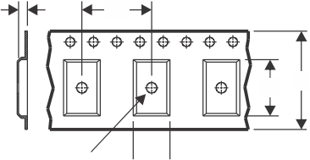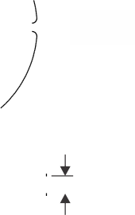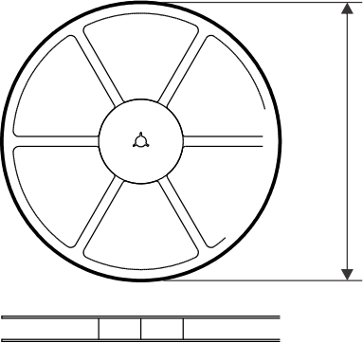
TAPE DIMENSIONS
K0 P1
W B0
Reel
Diameter
Cavity A0

A0 | Dimension designed to accommodate the component width
B0 | Dimension designed to accommodate the component length
K0 | Dimension designed to accommodate the component thickness
W | Overall width of the carrier tape
P1 | Pitch between successive cavity centers

REEL DIMENSIONS
Reel Width (W1)
QUADRANT ASSIGNMENTS FOR PIN 1 ORIENTATION IN TAPE
4— Sprocket Holes
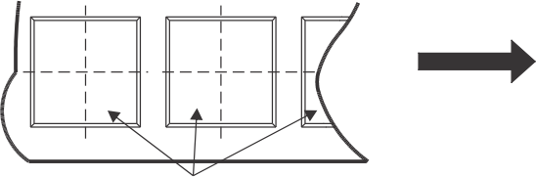
User Direction of Feed
Q1
Q3
Q2
Q4
Q1
Q3
Q2
Q4
Pocket Quadrants

*All dimensions are nominal

Device | Package  Type | Package  Drawing | Pins | SPQ | Reel  Diameter  (mm) | Reel  Width  W1 (mm) | A0  (mm) | B0  (mm) | K0  (mm) | P1  (mm) | W  (mm) | Pin1  Quadrant
SN65HVD230DR | SOIC | D | 8 | 2500 | 330.0 | 12.4 | 6.4 | 5.2 | 2.1 | 8.0 | 12.0 | Q1
SN65HVD231DR | SOIC | D | 8 | 2500 | 330.0 | 12.4 | 6.4 | 5.2 | 2.1 | 8.0 | 12.0 | Q1
SN65HVD232DR | SOIC | D | 8 | 2500 | 330.0 | 12.4 | 6.4 | 5.2 | 2.1 | 8.0 | 12.0 | Q1

www.ti.com 23-Dec-2025

TAPE AND REEL BOX DIMENSIONS

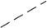
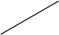
H

L
W

可

A

*All dimensions are nominal

Device | Package Type | Package Drawing | Pins | SPQ | Length (mm) | Width (mm) | Height (mm)
SN65HVD230DR | SOIC | D | 8 | 2500 | 353.0 | 353.0 | 32.0
SN65HVD231DR | SOIC | D | 8 | 2500 | 353.0 | 353.0 | 32.0
SN65HVD232DR | SOIC | D | 8 | 2500 | 353.0 | 353.0 | 32.0

D0008A

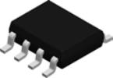

PACKAGE OUTLINE SOIC - 1.75 mm max height

SMALL OUTLINE INTEGRATED CIRCUIT

0 - 8
.016-.050 [0.41-1.27]
.004-.010 [0.11-0.25]
DETAIL A

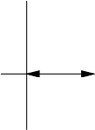
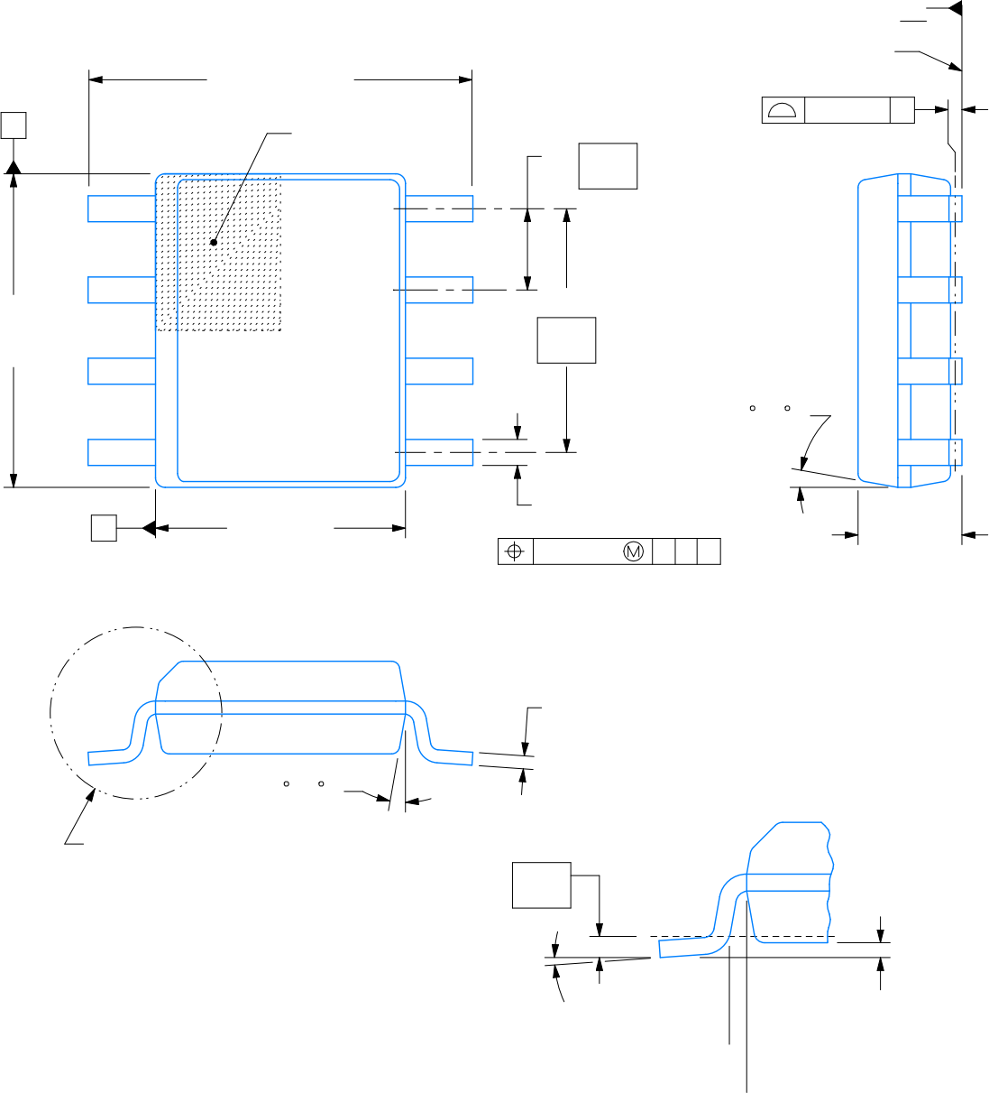 (.041) TYPICAL [1.04]
.005-.010 TYP
[0.13-0.25]

4X (0 -15 )

SEE DETAIL A
.010
[0.25]
.228-.244 TYP
[5.80-6.19]
PIN 1 ID AREA
6X .050
[1.27]
1 8
A

.189-.197 [4.81-5.00] NOTE 3
C
SEATING PLANE

.004 [0.1] C
5
8X .012-.020 [0.31-0.51]
.010 [0.25]
.150-.157 [3.81-3.98] NOTE 4
.069 MAX [1.75]
4

B
2X
.150 [3.81]
4X (0 -15 )
C A B
4214825/C 02/2019
NOTES:
1. Linear dimensions are in inches [millimeters]. Dimensions in parenthesis are for reference only. Controlling dimensions are in inches. Dimensioning and tolerancing per ASME Y14.5M.
2. This drawing is subject to change without notice.
3. This dimension does not include mold flash, protrusions, or gate burrs. Mold flash, protrusions, or gate burrs shall not exceed .006 [0. 15] per side.
4. This dimension does not include interlead flash.
5. Reference JEDEC registration MS-012, variation AA.

EXAMPLE BOARD LAYOUT D0008A SOIC - 1.75 mm max height

SMALL OUTLINE INTEGRATED CIRCUIT

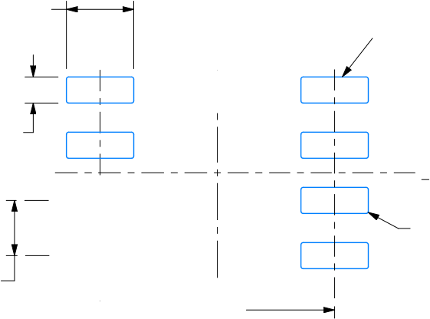
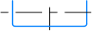
4 
SEE
DETAILS
8
(R.002 ) TYP [0.05]
SYMM
6X (.050 ) [1.27]
8X (.061 ) [1.55]
8X (.024) [0.6]
(.213) [5.4]
SYMM
5
1
LAND PATTERN EXAMPLE
EXPOSED METAL SHOWN
SCALE:8X
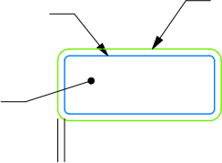 .0028 MAX [0.07]  SOLDER MASK OPENING  EXPOSED METAL  METAL  ALL AROUND  NON SOLDER MASK  DEFINED | .0028 MIN [0.07]  EXPOSED METAL  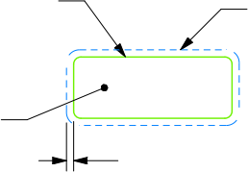  SOLDER MASK OPENING  METAL UNDER SOLDER MASK  ALL AROUND  SOLDER MASK DEFINED
SOLDER MASK DETAILS

4214825/C 02/2019
NOTES: (continued)
6. Publication IPC-7351 may have alternate designs.
7. Solder mask tolerances between and around signal pads can vary based on board fabrication site.

EXAMPLE STENCIL DESIGN D0008A SOIC - 1.75 mm max height

SMALL OUTLINE INTEGRATED CIRCUIT

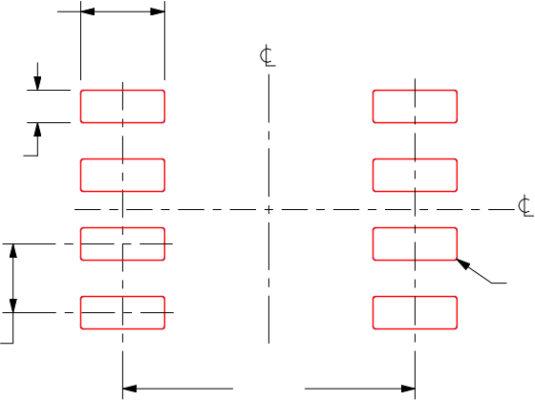
(R.002 ) TYP [0.05]
6X (.050 ) [1.27]
8X (.061 ) [1.55]
8X (.024) [0.6]
(.213) [5.4]
SYMM
SYMM
8
5
4
1

SOLDER PASTE EXAMPLE
BASED ON .005 INCH [0.125 MM] THICK STENCIL
SCALE:8X

4214825/C 02/2019
NOTES: (continued)
8. Laser cutting apertures with trapezoidal walls and rounded corners may offer better paste release. IPC-7525 may have alternate design recommendations.
9. Board assembly site may have different recommendations for stencil design.

IMPORTANT NOTICE AND DISCLAIMER
TI PROVIDES TECHNICAL AND RELIABILITY DATA (INCLUDING DATASHEETS), DESIGN RESOURCES (INCLUDING REFERENCE DESIGNS), APPLICATION OR OTHER DESIGN ADVICE, WEB TOOLS, SAFETY INFORMATION, AND OTHER RESOURCES “AS IS” AND WITH ALL FAULTS, AND DISCLAIMS ALL WARRANTIES, EXPRESS AND IMPLIED, INCLUDING WITHOUT LIMITATION ANY
IMPLIED WARRANTIES OF MERCHANTABILITY, FITNESS FOR A PARTICULAR PURPOSE OR NON-INFRINGEMENT OF THIRD PARTY INTELLECTUAL PROPERTY RIGHTS.
These resources are intended for skilled developers designing with TI products. You are solely responsible for (1) selecting the appropriate TI products for your application, (2) designing, validating and testing your application, and (3) ensuring your application meets applicable standards, and any other safety, security, regulatory or other requirements.
These resources are subject to change without notice. TI grants you permission to use these resources only for development of an
application that uses the TI products described in the resource. Other reproduction and display of these resources is prohibited. No license is granted to any other TI intellectual property right or to any third party intellectual property right. TI disclaims responsibility for, and you fully indemnify TI and its representatives against any claims, damages, costs, losses, and liabilities arising out of your use of these resources.
TI’s products are provided subject to TI’s Terms of Sale, TI’s General Quality Guidelines, or other applicable terms available either on
ti.com or provided in conjunction with such TI products. TI’s provision of these resources does not expand or otherwise alter TI’s applicable warranties or warranty disclaimers for TI products. Unless TI explicitly designates a product as custom or customer-specified, TI products are standard, catalog, general purpose devices.
TI objects to and rejects any additional or different terms you may propose.

Copyright © 2026, Texas Instruments Incorporated
Last updated 10/2025

